**DATA MODELLING**

**E-COMMERCE WEBSITE**

**DATABASE:**

CREATE DATABASE DTTC;

USE DTTC;

**USERS TABLE:**

CREATE TABLE USERS(

Name VARCHAR(25),

User_id INT,

Address VARCHAR(100),

Mobile_No LONG,

Mail_id VARCHAR(25),

PRIMARY KEY(User_id)

);

DESCRIBE USERS;

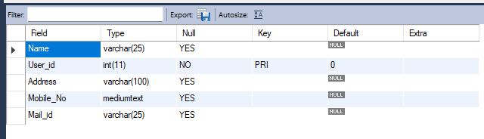

INSERT INTO USERS

VALUES

('Sneha', 123, 'xyz street,chennai-83.',9876543210,'sneha@gmail.com'),

('Meghaa', 133, 'abcz street,chennai-3.',9678543210,'meghaa@gmail.com'),

('Padma', 143, 'defz street,chennai-33.',9678543210,'padma@gmail.com'),

('Amala', 153, 'ghi street,chennai-83.',8976543210,'amala@gmail.com'),

('Joy', 163, 'xyz street,chennai-83.',8876542210,'joy@gmail.com'),

('Judes', 173, 'abcdz street,chennai-89.',9876544410,'judes@gmail.com'),

('Tanya', 183, 'hjrnf street,chennai-53.',7896543210,'tanya@gmail.com');

SELECT * FROM USERS;

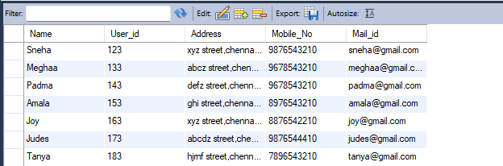

**PRODUCTS TABLE:**

CREATE TABLE PRODUCTS(

Name VARCHAR(25),

Category VARCHAR(25),

Product_id INT,

Price DOUBLE,

Size INT,

Brand VARCHAR(25),

Available LONG,

PRIMARY KEY(Product_id)

);

DESCRIBE PRODUCTS;

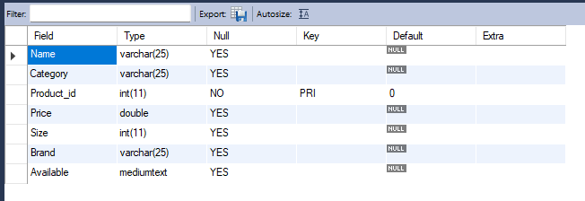

INSERT INTO PRODUCTS

VALUES

('White_Kurti','Women',111,1000,36,'Diva',500),

('Blueshirt','Men',121,1200,42,'PeterEngaland',300),

('Babysocks','Kids',131,100,25,'FirstCry',1000),

('SilkSaree','Women',141,10000,100,'Diadem',600),

('Kurta','Men',161,2000,44,'Luois Phillipe',500);

SELECT * FROM PRODUCTS;

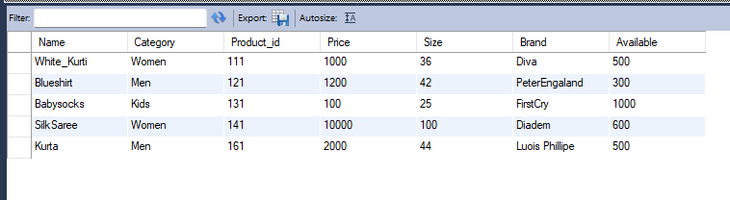

**ORDERS TABLE:**

CREATE TABLE ORDERS(

Order_id INT,

User_id INT,

Product_id INT,

Total_amount DOUBLE,

Delivery_address VARCHAR(100),

Contact_No LONG,

Order_status VARCHAR(25),

Quantity INT,

Delivery_time DATE,

Order_time DATE,

PRIMARY KEY(Order_id),

FOREIGN KEY(User_id) REFERENCES USERS(User_id),

FOREIGN KEY(Product_id) REFERENCES PRODUCTS(Product_id)

);

DESCRIBE ORDERS;

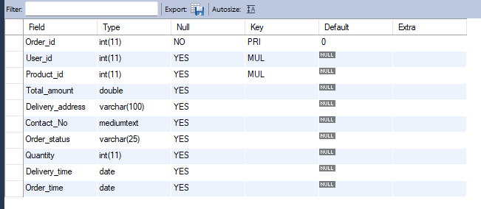

INSERT INTO ORDERS

VALUES

(201,123,111,2000,'xyz street,chennai-83.',9876543210,'Dispatched',2,'2022-09-18','2022-09-10'),

(202,143,161,6000,'defz street,chennai-33.',9678543210,'Ordered',3,'2022-09-25','2022-09-15');

SELECT * FROM ORDERS;

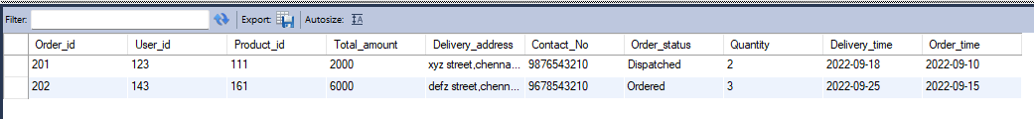

**ORDER_DETAILS:**

CREATE TABLE ORDER_DETAILS(

Product_id INT,

Order_id INT,

Product_name VARCHAR(25),

Quantity INT,

Price DOUBLE,

Total_amount DOUBLE,

FOREIGN KEY(Product_id) REFERENCES PRODUCTS(Product_id),

FOREIGN KEY(Order_id) REFERENCES ORDERS(Order_id)

);

DESCRIBE ORDER_DETAILS;

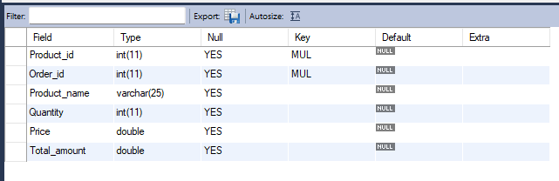

INSERT INTO ORDER_DETAILS

VALUES

(111,201,'White_Kurti',2,1000,2000),

(161,202,'Kurta',3,2000,6000);

SELECT * FROM ORDER_DETAILS;

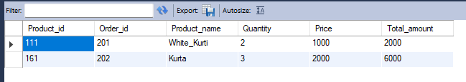

**PAYMENT:**

CREATE TABLE PAYMENT(

Payment_id INT,

Total_amount DOUBLE,

MOP VARCHAR(25),

Order_id INT,

Transaction_status VARCHAR(25),

Refund_status VARCHAR(25),

PRIMARY KEY(Payment_id),

FOREIGN KEY(Order_id) REFERENCES ORDERS(Order_id)

);

DESCRIBE PAYMENT;

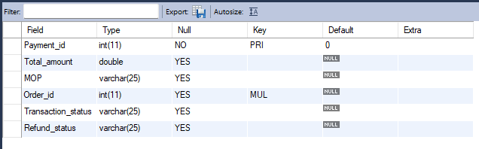

INSERT INTO PAYMENT

VALUES

(404,2000,'Cash on Delivery',201,'Success','Refund required'),

(505,6000,'Credit Card',202,'Failed','No refund'),

(606,6000,'UPI',202,'Success','No refund');

SELECT * FROM PAYMENT;

